NAAN MUDHALVAN ASSIGNMENT

**NAME:** THIRUVARASAN VR

**DEPARTMENT:** COMPUTER SCIENCE AND ENGINEERING

**COLLEGE:** DHANALAKSHMI SRINIVASAN INSTITUTE OF TECHNOLOGY

**NAAN MUDHALVAN COURSE:** DIGITAL MARKETING

**NM ID:**8555D655B967DF59C4A4E565EDF4A826

**ASSINGMENT 1:**

Create a blog or website using blogspot and wordpress. Customize the theme design and post new article with 500 words

URL:<https://mensprt.blogspot.com/2023/08/thiru-sports.html>

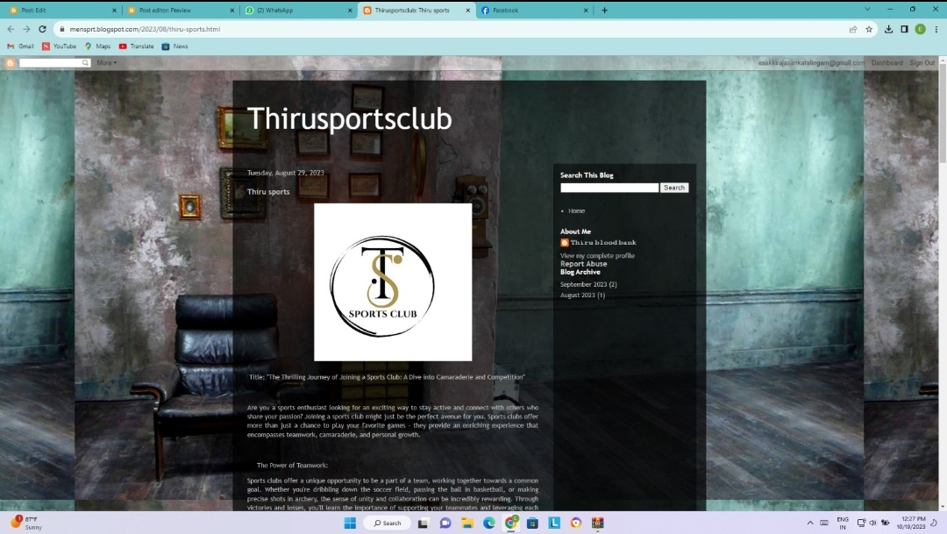

**ASSINGMENT 2:**

Create a new Facebook business page and post one social media poster for your brand.

**URL:**<https://www.facebook.com/dolphin.aqu?mibextid=9R9pXO>

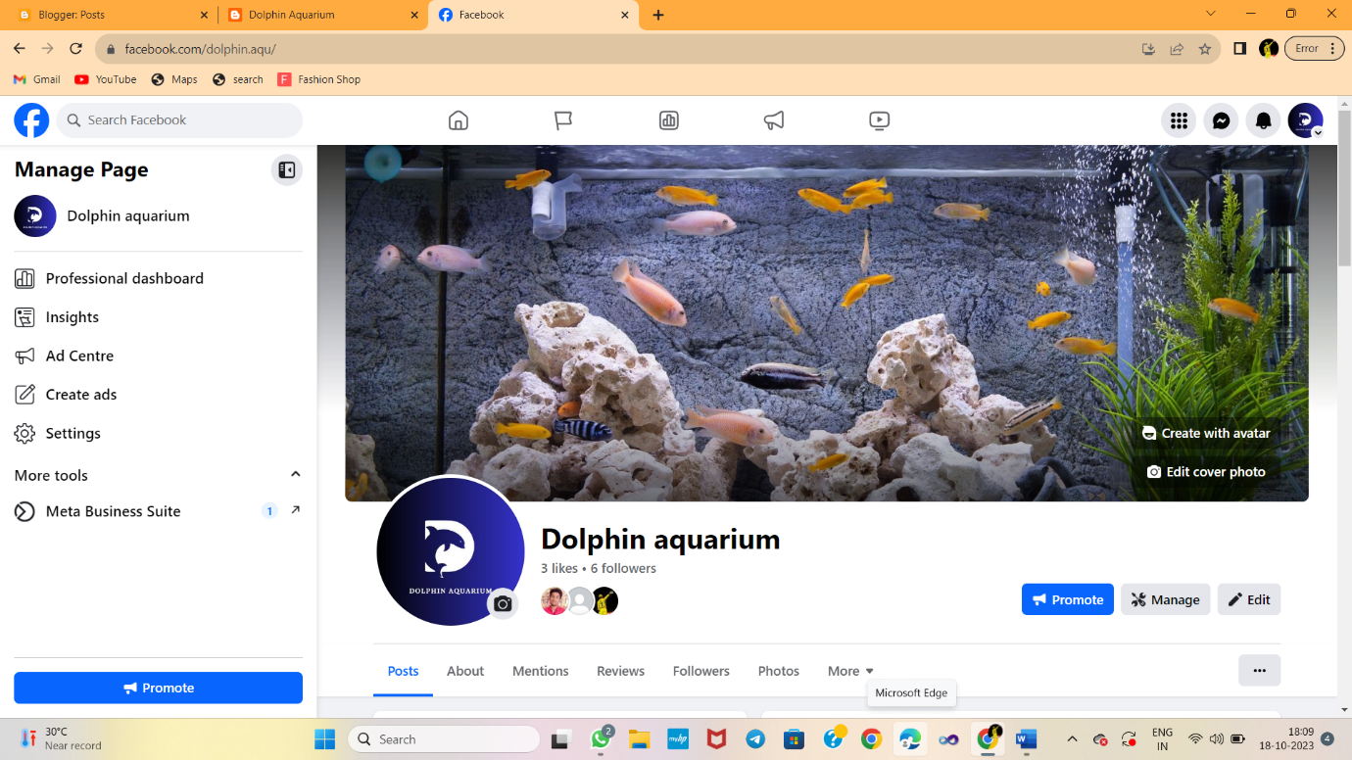

**ASSIGNMENT 3:**

Create and design a advertisement poster using canva.

**URL:**<https://mensprt.blogspot.com/2023/09/infographics.html>

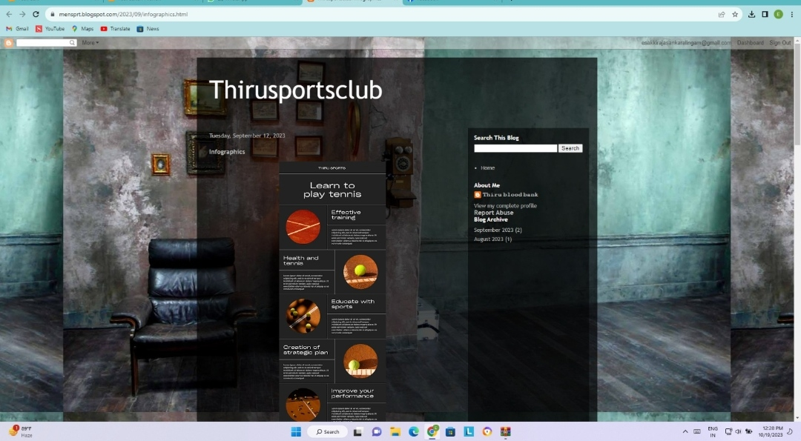

**ASSIGNMENT 4:**

CreateanEmailnewsletterdesignusingMailchimporCanvatool

**URL:**<https://mensprt.blogspot.com/2023/09/news-letter.html>

